NamaPeserta : I Ketut Muliana

Kode Peserta : FSDO001ONL011

Tugas : Assigment 2

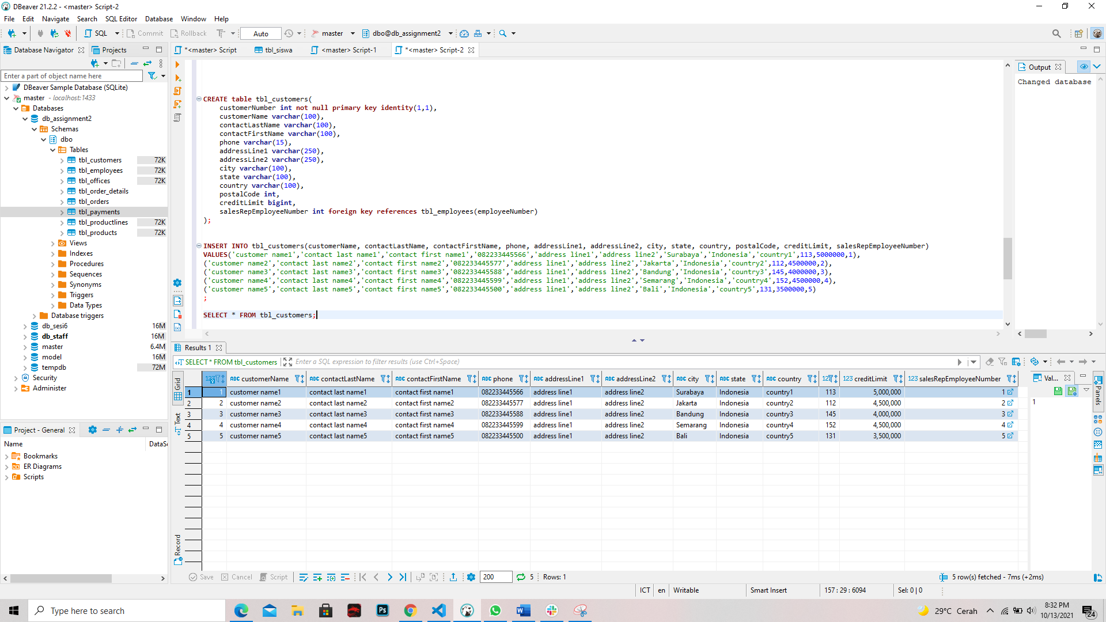No. 1 - Customers => stores data customer

Jawaban Query Soal No. 1

**CREATE** **table** tbl_customers(

customerNumber **int** **not** **null** **primary** **key** **identity**(1,1),

customerName **varchar**(100),

contactLastName **varchar**(100),

contactFirstName **varchar**(100),

phone **varchar**(15),

addressLine1 **varchar**(250),

addressLine2 **varchar**(250),

city **varchar**(100),

state **varchar**(100),

country **varchar**(100),

postalCode **int**,

creditLimit **bigint**,

salesRepEmployeeNumber **int** **foreign** **key** **references** tbl_employees(employeeNumber)

);

**INSERT** **INTO** tbl_customers(customerName, contactLastName, contactFirstName, phone, addressLine1, addressLine2, city, state, country, postalCode, creditLimit, salesRepEmployeeNumber)

**VALUES**('customer name1','contact last name1','contact first name1','082233445566','address line1','address line2','Surabaya','Indonesia','country1',113,5000000,1),

('customer name2','contact last name2','contact first name2','082233445577','address line1','address line2','Jakarta','Indonesia','country2',112,4500000,2),

('customer name3','contact last name3','contact first name3','082233445588','address line1','address line2','Bandung','Indonesia','country3',145,4000000,3),

('customer name4','contact last name4','contact first name4','082233445599','address line1','address line2','Semarang','Indonesia','country4',152,4500000,4),

('customer name5','contact last name5','contact first name5','082233445500','address line1','address line2','Bali','Indonesia','country5',131,3500000,5)

;

**SELECT** * **FROM** tbl_customers;

-------------------

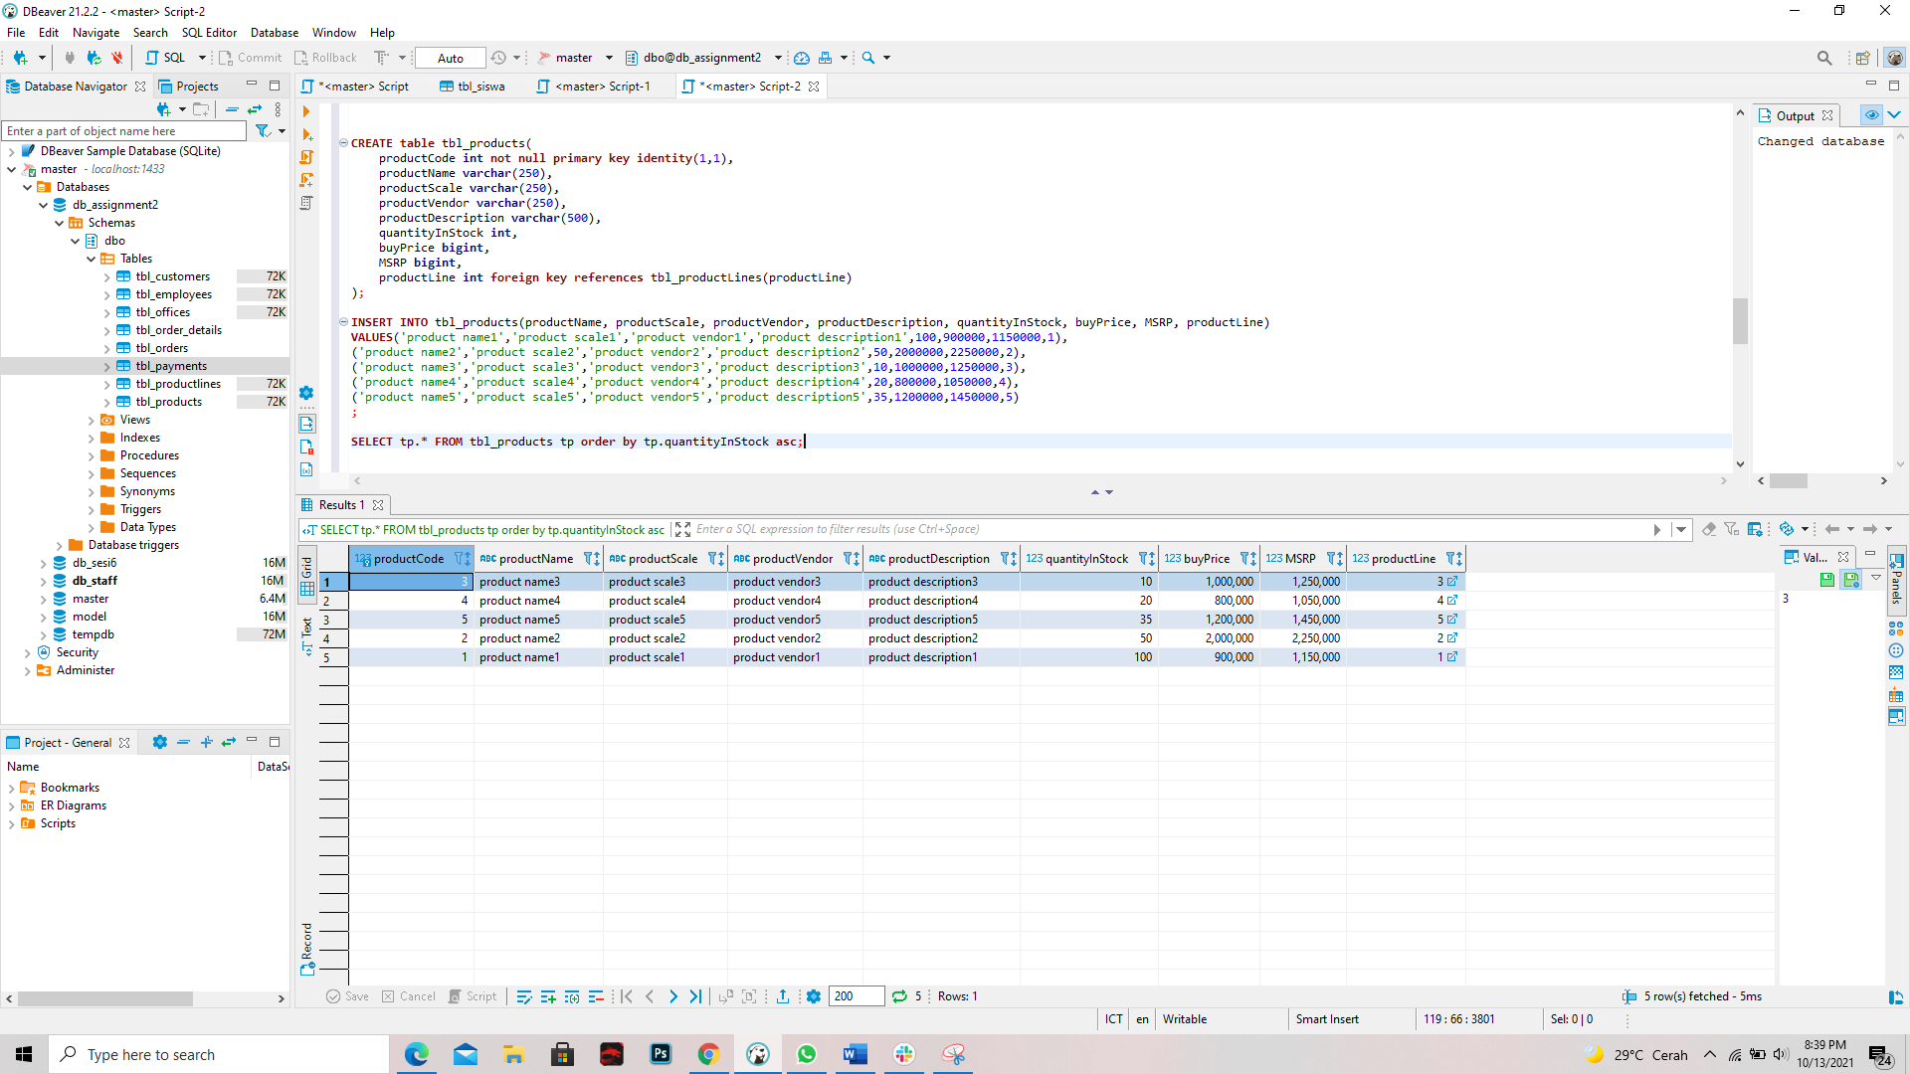

No.2 - Products => stores daftar/list model product ( dalam hal ini bisa mobil/motor dll )**CREATE** **table** tbl_products(

productCode **int** **not** **null** **primary** **key** **identity**(1,1),

productName **varchar**(250),

productScale **varchar**(250),

productVendor **varchar**(250),

productDescription **varchar**(500),

quantityInStock **int**,

buyPrice **bigint**,

MSRP **bigint**,

productLine **int** **foreign** **key** **references** tbl_productLines(productLine)

);

**INSERT** **INTO** tbl_products(productName, productScale, productVendor, productDescription, quantityInStock, buyPrice, MSRP, productLine)

**VALUES**('product name1','product scale1','product vendor1','product description1',100,900000,1150000,1),

('product name2','product scale2','product vendor2','product description2',50,2000000,2250000,2),

('product name3','product scale3','product vendor3','product description3',10,1000000,1250000,3),

('product name4','product scale4','product vendor4','product description4',20,800000,1050000,4),

('product name5','product scale5','product vendor5','product description5',35,1200000,1450000,5)

;

**SELECT** tp.* **FROM** tbl_products tp **order** **by** tp.quantityInStock **asc**;

-------------------

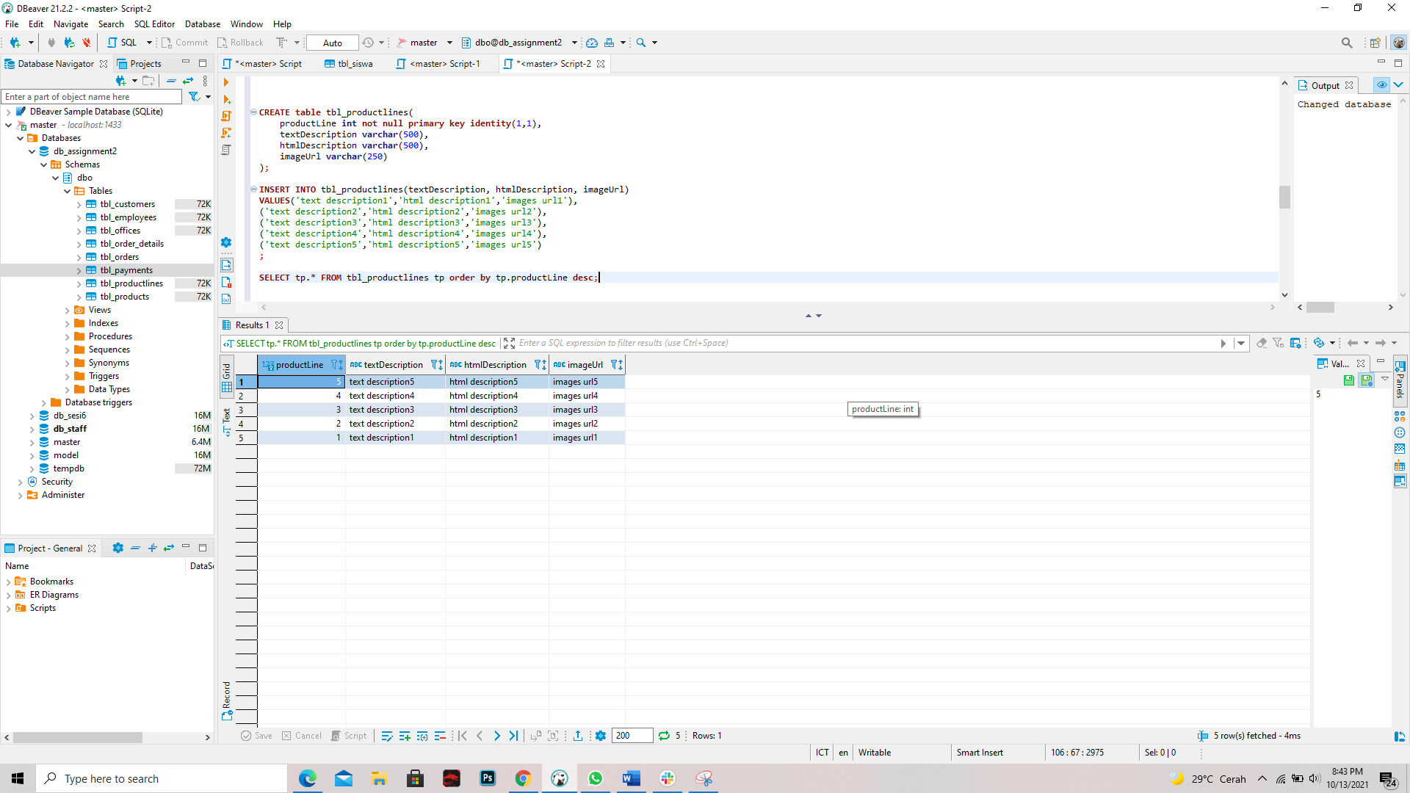

No. 3 - Productlines => stores daftar/list kategori product

**CREATE** **table** tbl_productlines(

productLine **int** **not** **null** **primary** **key** **identity**(1,1),

textDescription **varchar**(500),

htmlDescription **varchar**(500),

imageUrl **varchar**(250)

);

**INSERT** **INTO** tbl_productlines(textDescription, htmlDescription, imageUrl)

**VALUES**('text description1','html description1','images url1'),

('text description2','html description2','images url2'),

('text description3','html description3','images url3'),

('text description4','html description4','images url4'),

('text description5','html description5','images url5')

;

**SELECT** tp.* **FROM** tbl_productlines tp **order** **by** tp.productLine **desc**;

-------------------

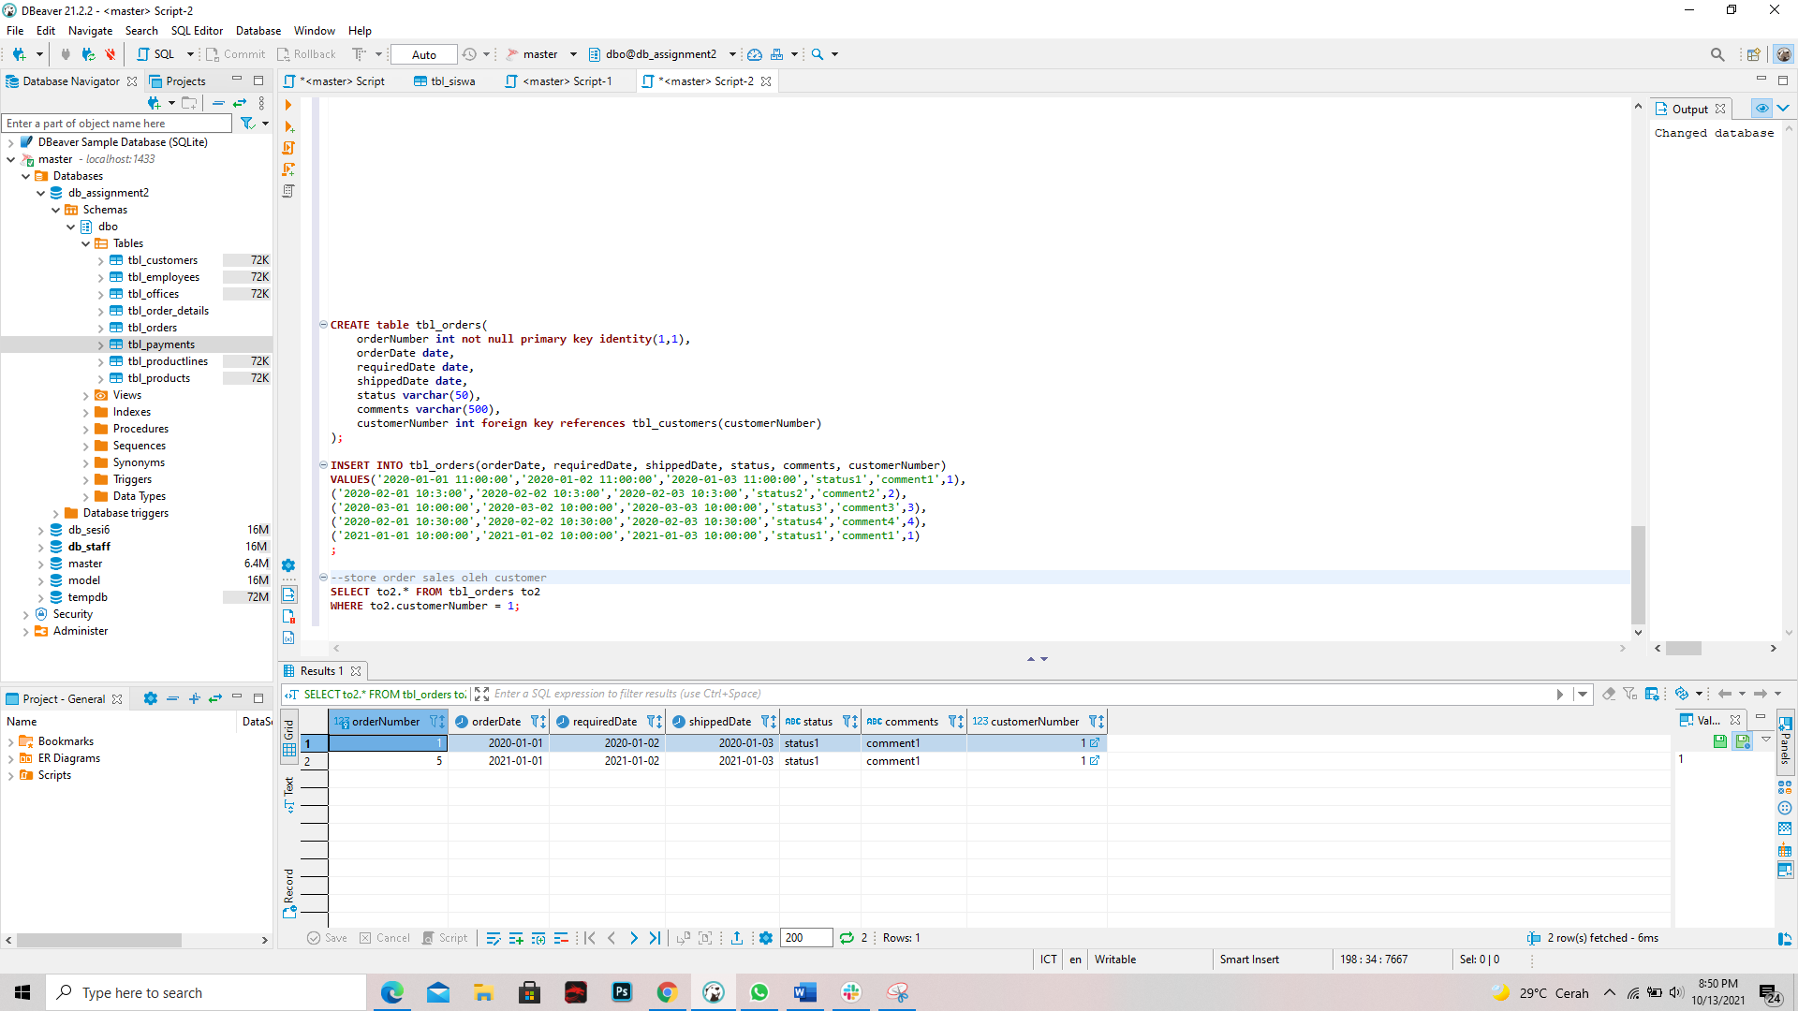

No. 4 - Orders => store Order Sales oleh customer**CREATE** **table** tbl_orders(

orderNumber **int** **not** **null** **primary** **key** **identity**(1,1),

orderDate **date**,

requiredDate **date**,

shippedDate **date**,

status **varchar**(50),

comments **varchar**(500),

customerNumber **int** **foreign** **key** **references** tbl_customers(customerNumber)

);

**INSERT** **INTO** tbl_orders(orderDate, requiredDate, shippedDate, status, comments, customerNumber)

**VALUES**('2020-01-01 11:00:00','2020-01-02 11:00:00','2020-01-03 11:00:00','status1','comment1',1),

('2020-02-01 10:3:00','2020-02-02 10:3:00','2020-02-03 10:3:00','status2','comment2',2),

('2020-03-01 10:00:00','2020-03-02 10:00:00','2020-03-03 10:00:00','status3','comment3',3),

('2020-02-01 10:30:00','2020-02-02 10:30:00','2020-02-03 10:30:00','status4','comment4',4),

('2021-01-01 10:00:00','2021-01-02 10:00:00','2021-01-03 10:00:00','status1','comment1',1)

;

--store order sales oleh customer

**SELECT** to2.* **FROM** tbl_orders to2

**WHERE** to2.customerNumber = 1;

-------------------

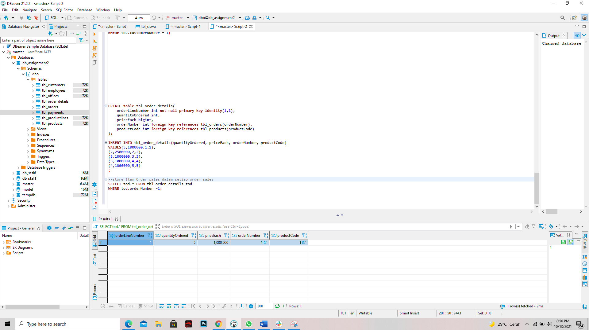

No. 5 - OrderDetails => store Item Order sales dalam setiap order sales

**CREATE** **table** tbl_order_details(

orderLineNumber **int** **not** **null** **primary** **key** **identity**(1,1),

quantityOrdered **int**,

priceEach **bigint**,

orderNumber **int** **foreign** **key** **references** tbl_orders(orderNumber),

productCode **int** **foreign** **key** **references** tbl_products(productCode)

);

**INSERT** **INTO** tbl_order_details(quantityOrdered, priceEach, orderNumber, productCode)

**VALUES**(5,1000000,1,1),

(2,2500000,2,2),

(5,1000000,3,3),

(3,1000000,4,4),

(4,1000000,5,5)

;

--store Item Order sales dalam setiap order sales

**SELECT** tod.* **FROM** tbl_order_details tod

**WHERE** tod.orderNumber =1;

-------------------

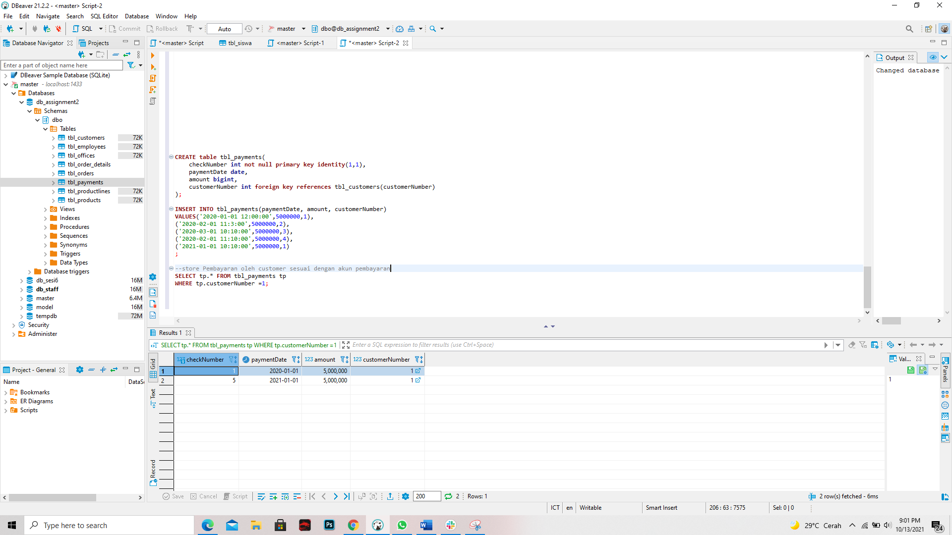

No. 6 - Payments => store Pembayaran oleh customer sesuai dengan akun pembayaran

**CREATE** **table** tbl_payments(

checkNumber **int** **not** **null** **primary** **key** **identity**(1,1),

paymentDate **date**,

amount **bigint**,

customerNumber **int** **foreign** **key** **references** tbl_customers(customerNumber)

);

**INSERT** **INTO** tbl_payments(paymentDate, amount, customerNumber)

**VALUES**('2020-01-01 12:00:00',5000000,1),

('2020-02-01 11:3:00',5000000,2),

('2020-03-01 10:10:00',5000000,3),

('2020-02-01 11:10:00',5000000,4),

('2021-01-01 10:10:00',5000000,1)

;

--store Pembayaran oleh customer sesuai dengan akun pembayaran

**SELECT** tp.* **FROM** tbl_payments tp

**WHERE** tp.customerNumber =1;

-------------------

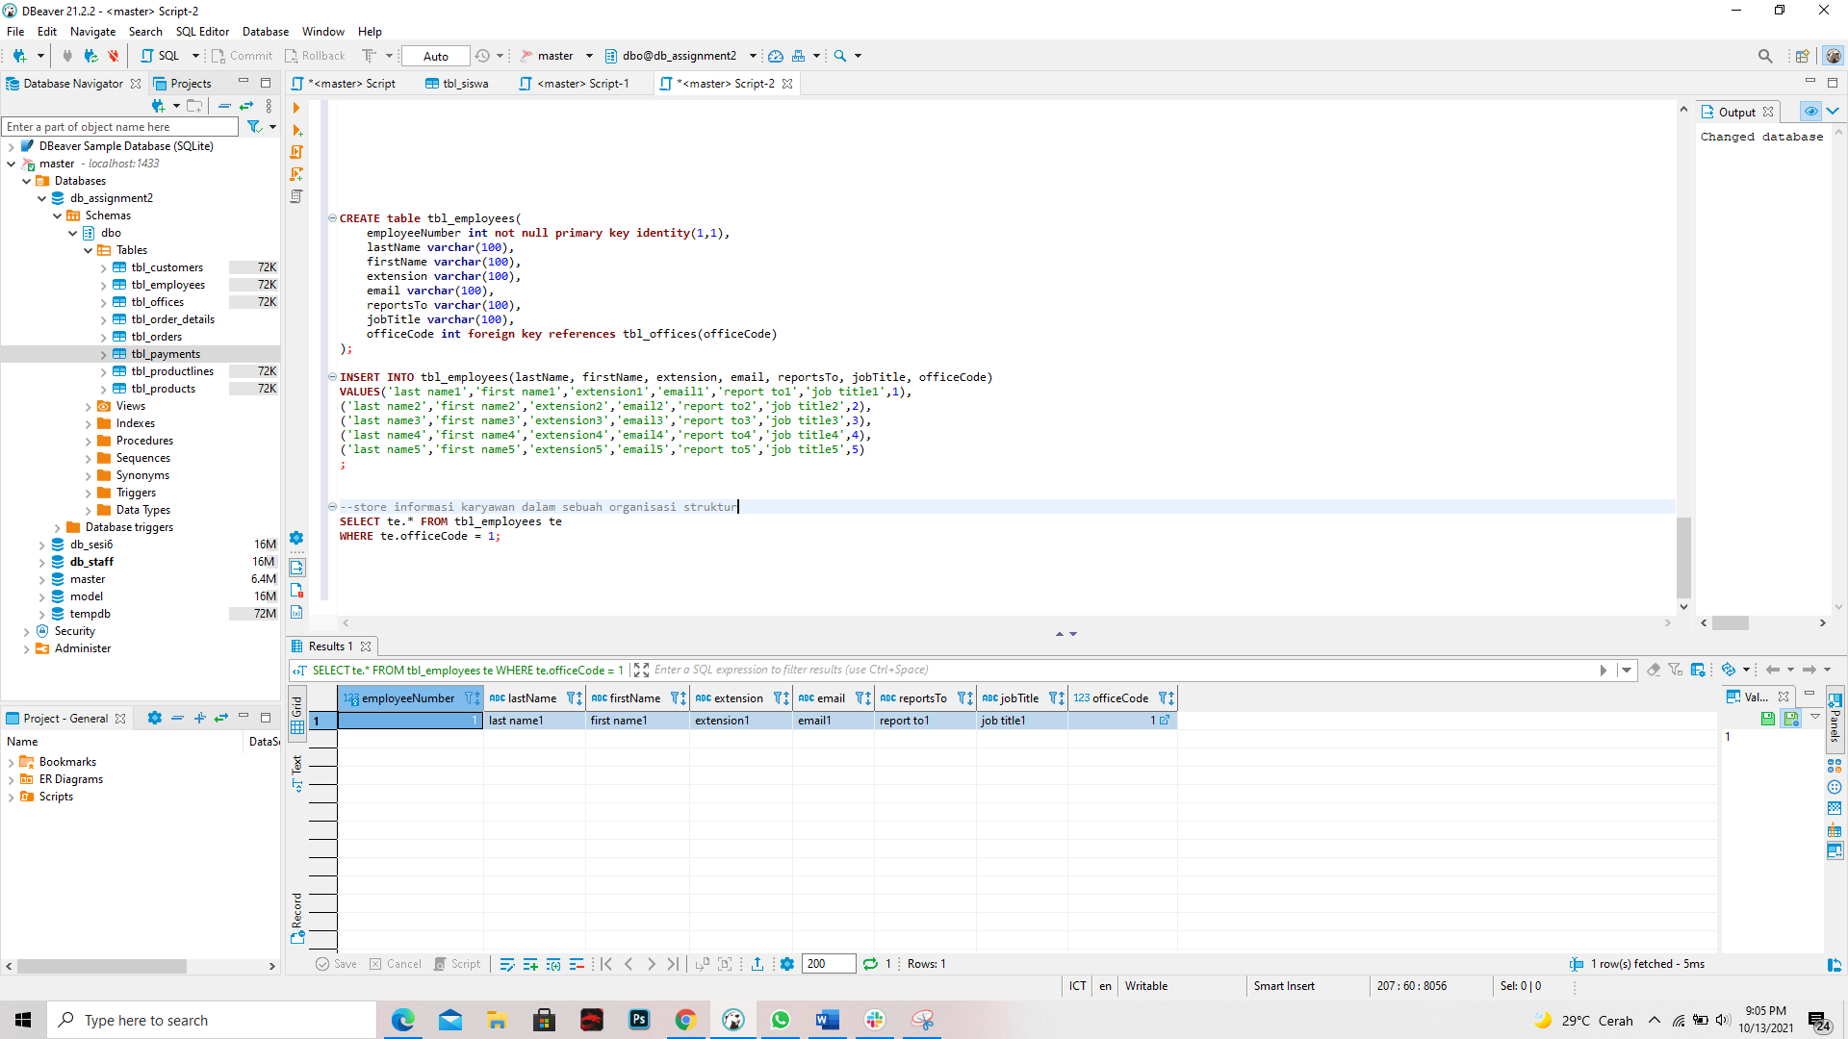

No. 7 - Employee => store informasi karyawan dalam sebuah organisasi struktur**CREATE** **table** tbl_employees(

employeeNumber **int** **not** **null** **primary** **key** **identity**(1,1),

lastName **varchar**(100),

firstName **varchar**(100),

extension **varchar**(100),

email **varchar**(100),

reportsTo **varchar**(100),

jobTitle **varchar**(100),

officeCode **int** **foreign** **key** **references** tbl_offices(officeCode)

);

**INSERT** **INTO** tbl_employees(lastName, firstName, extension, email, reportsTo, jobTitle, officeCode)

**VALUES**('last name1','first name1','extension1','email1','report to1','job title1',1),

('last name2','first name2','extension2','email2','report to2','job title2',2),

('last name3','first name3','extension3','email3','report to3','job title3',3),

('last name4','first name4','extension4','email4','report to4','job title4',4),

('last name5','first name5','extension5','email5','report to5','job title5',5)

;

--store informasi karyawan dalam sebuah organisasi struktur

**SELECT** te.* **FROM** tbl_employees te

**WHERE** te.officeCode = 1;

-------------------

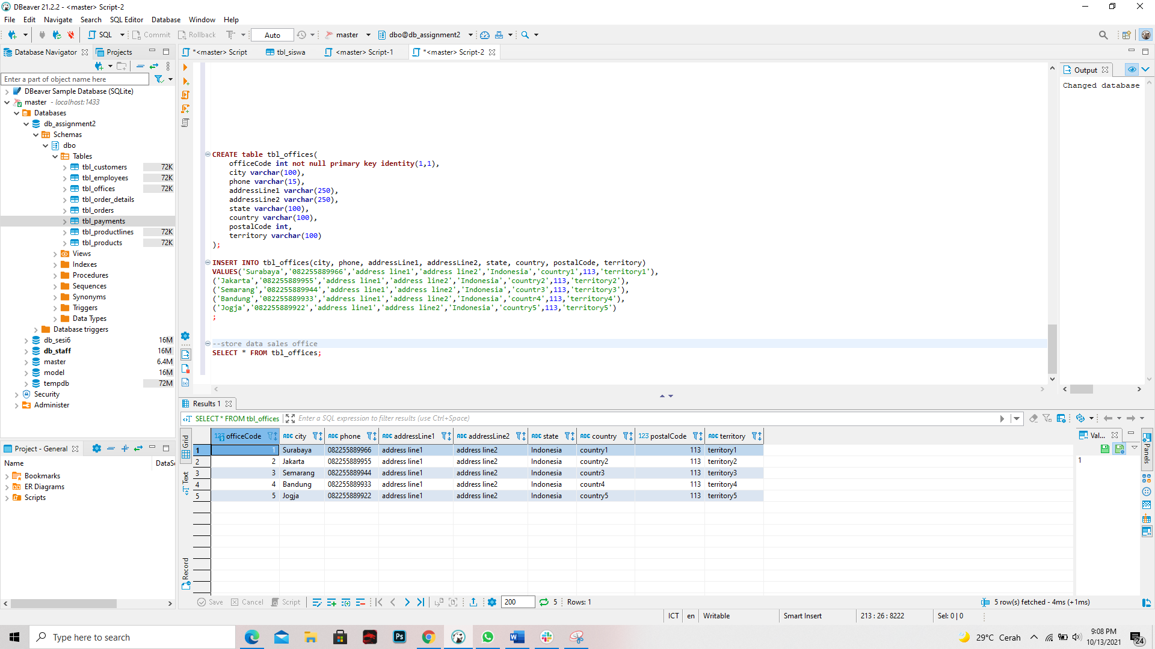

No. 8 - Offices => store data sales office

**CREATE** **table** tbl_offices(

officeCode **int** **not** **null** **primary** **key** **identity**(1,1),

city **varchar**(100),

phone **varchar**(15),

addressLine1 **varchar**(250),

addressLine2 **varchar**(250),

state **varchar**(100),

country **varchar**(100),

postalCode **int**,

territory **varchar**(100)

);

**INSERT** **INTO** tbl_offices(city, phone, addressLine1, addressLine2, state, country, postalCode, territory)

**VALUES**('Surabaya','082255889966','address line1','address line2','Indonesia','country1',113,'territory1'),

('Jakarta','082255889955','address line1','address line2','Indonesia','country2',113,'territory2'),

('Semarang','082255889944','address line1','address line2','Indonesia','countr3',113,'territory3'),

('Bandung','082255889933','address line1','address line2','Indonesia','countr4',113,'territory4'),

('Jogja','082255889922','address line1','address line2','Indonesia','country5',113,'territory5')

;

--store data sales office

**SELECT** * **FROM** tbl_offices;